**LAB PRACTICE REPORT 1**

**OBJECT ORIENTED PROGRAMMING**

2.2.1 First Java application

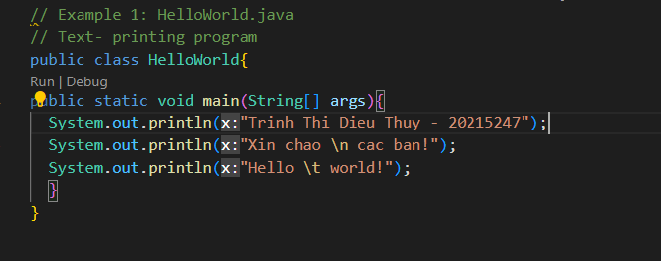

Result

2.2.2. First dialog Java program

Result

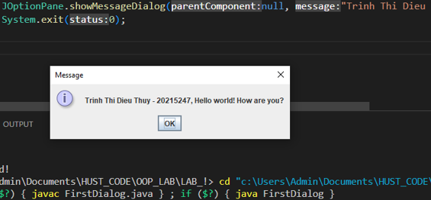

2.2.3. The first input dialog Java application

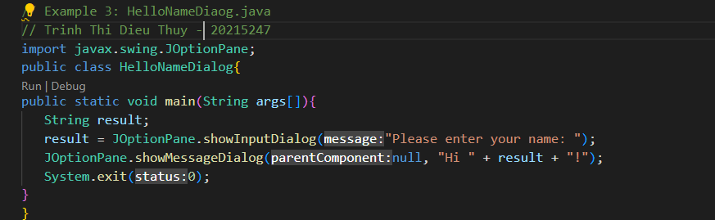

Result

2.2.4. Show two numbers

Result

2.2.5. A program to calculate sum, difference, product, and quotient of 2 double numbers which are entered by users

Result

2.2.6

Result:

6. Exercise

6.1. Write, compile and run the ChoosingOption program

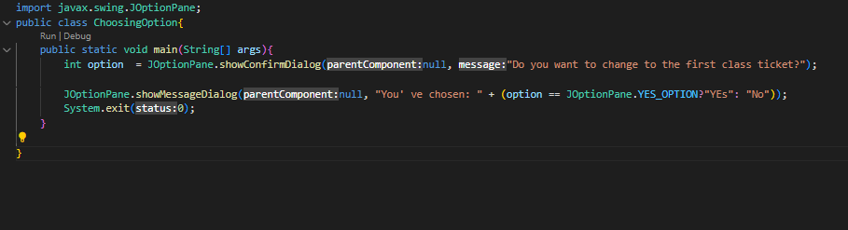

Result

6.2. Write a program for input/output from keyboard

Result

6.3 Write a program to display a triangle with a height of n stars (*), n is entered by users

Result

*6.4* ***Write a program to display the number of days of a month***

Result

6.5 Write a Java program to sort a numeric array, and calculate the sum and average value of arrayelements.

( next page)

Result

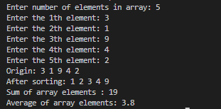

6.6 Write a Java program to add two matrices of the same size

Result

